Department of Computer Science and Engineering (Data Science)
CSDS-A | Batch A4 (CSE - Data Science, Section A)
Advanced Optimization in E-Commerce Logistics: Combining Matheuristics With Random Forests for Hub Location Efficiency
(HubOptima)
S.No. | Student name | Roll / hall ticket no.
1 | CH.ARCHANA | 23K91A6745
2 | A.MEENAKSHI | 23K91A6705
3 | B.ARUN | 23K91A6734
4 | A.SAMPATH | 23K91A6712
Under the guidance of: [GUIDE NAME], [DESIGNATION]
SCOPE AND LIMITATIONS
This document states what HubOptima covers and what it deliberately does not, the assumptions behind the design, and the honest limitations of the system and of the evidence for it.

1 Scope

1.1 In scope
- A synthetic but realistic monthly demand history for 90 regions (30 Indian cities and 60 satellite districts) over 36 months, with growth, festival peaks, promotions and noise, and the preprocessing that a real file of the same schema would need.
- A Random Forest demand forecaster with lag, rolling, seasonal, promotion and region features, evaluated on a time-based hold-out of six months against two naive forecasters.
- A capacitated single-allocation hub location model with fixed hub cost, transport cost, a delivery-time penalty, hub capacity, a limit of p hubs and an optional hard service-level constraint.
- A matheuristic (greedy/k-medoids construction, MIP-priced local search, kernel search) and the exact MIP as the traditional reference.
- Four baseline methods: greedy heuristic, k-means clustering, a 'largest markets' rule and a planning-on-historical-average method with no forecast.
- A rolling-horizon simulation over six months and a scalability benchmark with 90, 180 and 270 demand points.
- A FastAPI service with 14 endpoints, a React web application with seven screens, and a command-line interface.

1.2 Out of scope
- Real company data. No real order history was available; all figures are produced on the synthetic data and must not be read as field measurements.
- Vehicle routing, multi-echelon networks, hub-to-hub flows and economies of scale between hubs (the model is single-allocation: each region is served by exactly one hub).
- Robust or stochastic optimisation and the 'network robustness' indicator reported by the base paper.
- Multiple capacity levels for a hub, capacity expansion over time and hub-disruption scenarios.
- Real-time data feeds, user accounts, authentication and multi-user deployment.
- Forecasting models other than the Random Forest (deep learning, gradient boosting) and hyper-parameter search.

2 System Boundary
The context diagram and the use-case diagram show the boundary of HubOptima: what flows across it and who may do what inside it.
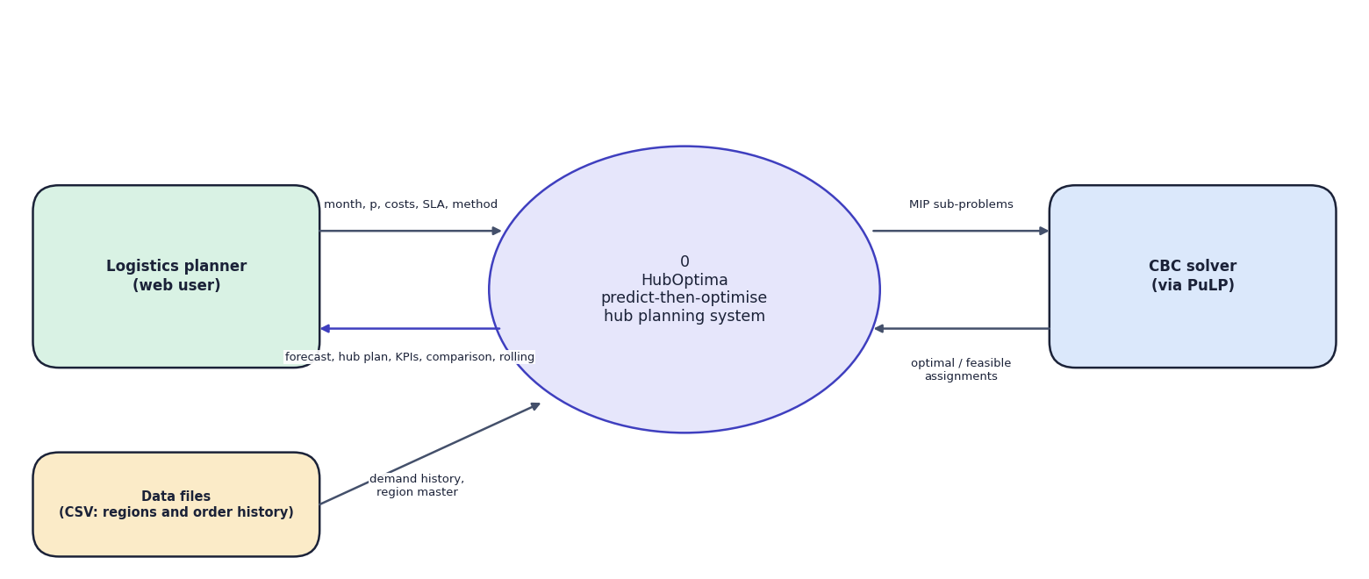
Fig. 1: Data-flow diagram, level 0 (context)
The context diagram shows HubOptima as one process with three external entities. The logistics planner supplies the planning month, the number of hubs, cost and service parameters and the method, and receives forecasts, hub plans, KPIs, comparisons and rolling results. The data files supply the region master and the order history. The CBC solver receives mixed-integer sub-problems and returns optimal or feasible assignments.
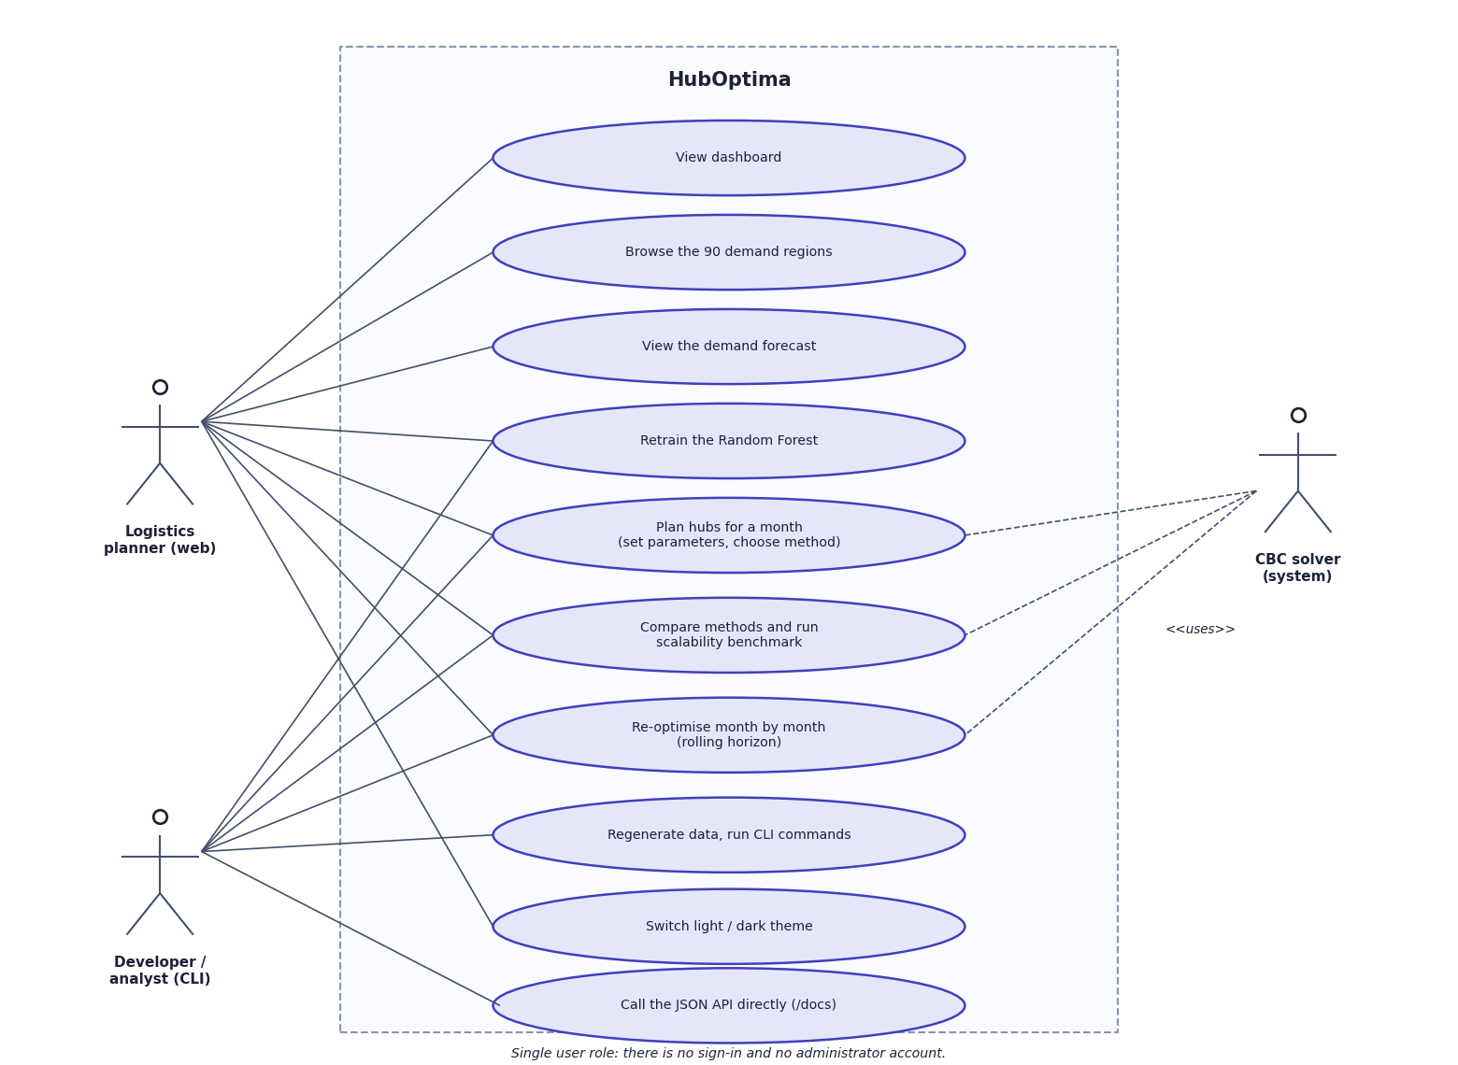
Fig. 2: Use-case diagram
The logistics planner browses the dashboard and regions, views and retrains the forecast, plans hubs, compares methods, runs the scalability benchmark, re-optimises over time and switches the theme. The developer or analyst uses the command line for the same functions and for regenerating the data, and may call the JSON API directly. The CBC solver is a system actor used by planning, comparison and re-optimisation.

3 Limitations and Assumptions

3.1 Assumptions
- Demand in a region is the monthly number of orders; one order is one parcel of the same size.
- Road distance is 1.25 times the great-circle (haversine) distance; trucks average 45 km/h; a hub needs 6 hours of handling.
- Each region is served by exactly one hub (single allocation); every region can host a hub.
- A hub's capacity is 1.25 times the average planned demand per hub; fixed hub cost is INR 2.5 million per month scaled by city tier (1.35, 1.0, 0.75).
- Costs are model parameters (INR 0.04 per order-km, INR 1.5 per order-hour). They are plausible but not calibrated to any real carrier.

3.2 Limitations
- Synthetic data. The demand process was generated by the project, so the Random Forest learns a process the authors wrote down. The forecast accuracy (MAPE 7.67%) is therefore not evidence of accuracy on real data.
- Forecast error is not handled by the optimiser. The plan trusts the forecast. In the October 2025 peak the forecast was 13.2% low and three of six hubs ran above capacity (fulfilment 92.3%).
- Little gain from the matheuristic at 90 nodes. The matheuristic and the exact MIP found the same plan and solved in comparable times; the speed advantage appears from 180 nodes, and at 270 nodes the matheuristic was 3.67% above the exact incumbent.
- No robustness analysis. The base paper's robustness indicator was not implemented or measured.
- Single hold-out. There is one six-month hold-out split; no cross-validation or hyper-parameter search was run.
- No user study. The web application was exercised by scripted walkthroughs only; no real planner has evaluated it.
- Local deployment. There is no database, authentication or multi-user support; results are files on disk that background jobs overwrite.

4 Limits of the Testing Done
- No automated tests of the React frontend; it was checked by walkthroughs and a production build only.
- No concurrent-user or load test, no memory profile and only one machine; timings will differ elsewhere.
- No cross-validation or repeated seeds for the forecaster, and no statistical tests; the 18 smoke checks and 4 unit tests verify behaviour, not accuracy.
- The experiments of Chapter 8 are single runs on one synthetic dataset; run-to-run solve times vary by several seconds.
- Security was reviewed, not attacked.
- No user acceptance study.

5 Limitations of the Results
- All results come from one synthetic dataset and one random seed; absolute rupee values, delivery hours and fulfilment are model outputs.
- Fulfilment and SLA reliability are simulated capacity measures, not observed deliveries.
- The comparison covers a single month (October 2025); the rolling horizon covers six months; the benchmark three sizes.
- The base paper's real-data results are not reproduced and its robustness measure is not implemented.
- No confidence intervals, repeated runs or statistical tests; solve times vary by several seconds from run to run.

